Project Planning Phase
Project Planning Template (Product Backlog, Sprint Planning, Stories, Story points)

Date | 6 March 2026
Team ID | LTVIP2026TMIDS88565
Project Name | BookNest: Where Stories Nestle
Maximum Marks | 5 Marks

Product Backlog, Sprint Schedule, and Estimation (4 Marks)
Use the below template to create product backlog and sprint schedule
Sprint | Functional Requirement (Epic) | User Story Number | User Story / Task | Story Points | Priority | Team Members
Sprint-1 | Registration | USN-1 | As a user, I can register for the application by entering my email, password, and confirming my password. | 2 | High | 1
Sprint-1 | Registration | USN-2 | As a user, I will receive confirmation email once I have registered for the application | 1 | High | 1
Sprint-2 | Registration | USN-3 | As a user, I can register for the application through Facebook | 2 | Low | 1
Sprint-1 | Registration | USN-4 | As a user, I can register for the application through Gmail | 2 | Medium | 1
Sprint-1 | Login | USN-5 | As a user, I can log into the application by entering email & password | 1 | High | 1
Sprint-2 | Dashboard | USN-6 | As a user, I can view personalized book recommendations on my dashboard. | 3 | High | 1
Sprint-2 | Dashboard | USN-7 | As a user, I can see my recent orders and wishlist on the dashboard. | 2 | Medium | 1
Sprint-3 | Book Search | USN-8 | As a user, I can search for books by title, author, or genre. | 2 | High | 1
Sprint-3 | Cart | USN-9 | As a user, I can add books to my cart and update quantities before checkout. | 2 | High | 1
Sprint-3 | Checkout | USN- 10 | As a user, I can checkout using saved addresses and pay securely. | 3 | High | 1

Project Tracker, Velocity & Burndown Chart: (4 Marks)
Sprint | Total Story Points | Duration | Sprint Start Date | Sprint End Date (Planned) | Story Points Completed (as on Planned End Date) | Sprint Release Date (Actual)
Sprint-1 | 20 | 6 Days | 24 June 2025 | 29 June 2025 | 20 | 29 June 2025
Sprint-2 | 20 | 6 Days | 31 June 2025 | 03 July 2025 | 20 | 03 July 2025
Sprint-3 | 20 | 6 Days | 05 July 2025 | 07 July 2025 | 20 | 07 July 2025
Sprint-4 | 20 | 6 Days | 14 July 2025 | 19 May 2025 | 20 | 19 July 2025

Velocity:
Imagine we have a 10-day sprint duration, and the velocity of the team is 20 (points per sprint). Let’s calculate the team’s average velocity (AV) per iteration unit (story points per day)
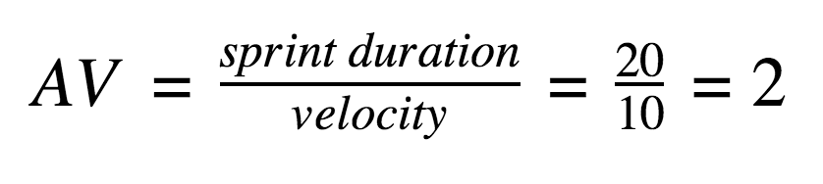

Burndown Chart:
A burn down chart is a graphical representation of work left to do versus time. It is often used in agile software development methodologies such as Scrum. However, burn down charts can be applied to any project containing measurable progress over time.

https://www.visual-paradigm.com/scrum/scrum-burndown-chart/
https://www.atlassian.com/agile/tutorials/burndown-charts

Reference:
https://www.atlassian.com/agile/project-management
https://www.atlassian.com/agile/tutorials/how-to-do-scrum-with-jira-software
https://www.atlassian.com/agile/tutorials/epics
https://www.atlassian.com/agile/tutorials/sprints
https://www.atlassian.com/agile/project-management/estimation
https://www.atlassian.com/agile/tutorials/burndown-charts

